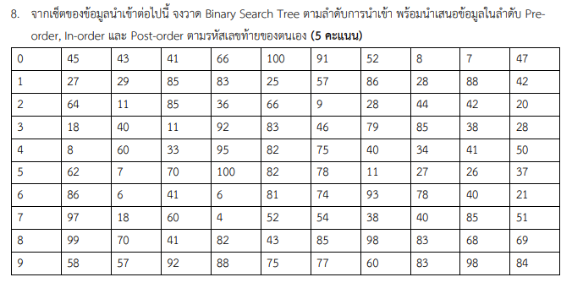



MY TREE :

Pre-order: 27, 25, 29, 28, 89, 83, 57, 42, 86, 88

In-order: 25, 27, 28, 29, 42, 57, 83, 86, 88, 89

Post-order: 25, 28, 42, 57, 88, 86, 83, 89, 29, 27